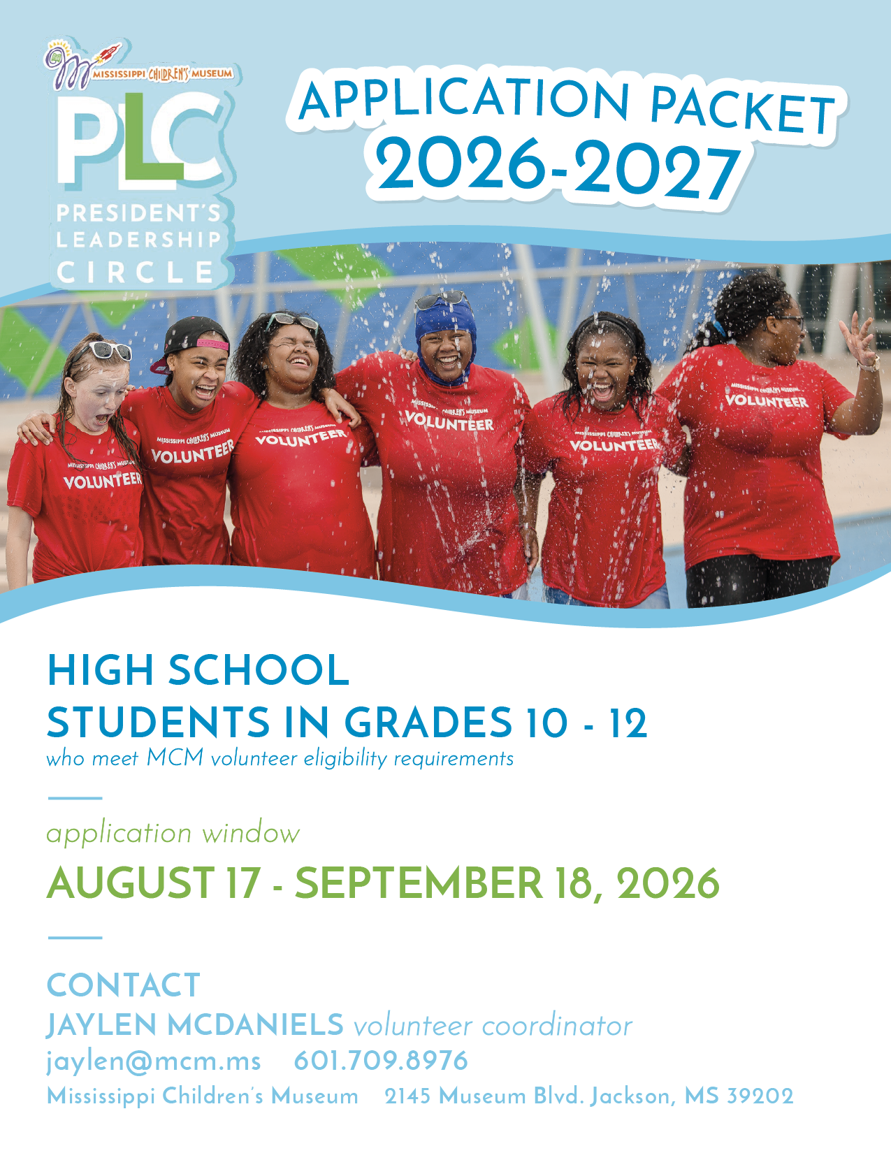

PROGRAM DESCRIPTION
president’s leadership circle

The President’s Leadership Circle (PLC) is a youth leadership and service program that develops high school students through structured volunteer service, leadership training, exposure to professionals, reflection, and civic engagement.
Strong PLC applicants demonstrate dependable service, initiative, thoughtful reflection, respect for others, realistic availability, and a willingness to lead by example.

THE FIVE PLC PILLARS
Leadership Skills | Community Service | Customer Service | Cultural Diversity | College & Career Readiness

ELIGIBILITY & DATES
WHO MAY APPLY | High school students in grades 10-12 who meet Mississippi Children’s Museum volunteer eligibility requirements
APPLICATION OPENS | Monday, August 17, 2026
APPLICATION DEADLINE | Friday, September 18, 2026
PROGRAM PERIOD | October 2026-May 2027
SERVICE REQUIREMENT | Service and attendance requirements will be communicated to selected participants
REQUIRED WITH PACKET | Student application, short responses, essay, student commitment, parent/guardian commitment, and nomination/recommendation

APPLICATION CHECKLIST
President’s Leadership Circle Program
1. Student Application and Availability  2. Service and Leadership Short Responses  3. Leadership Essay  4. Signed Student Commitment Form  5. Signed Parent/Guardian Commitment Form  6. Completed Nomination/Recommendation Form | 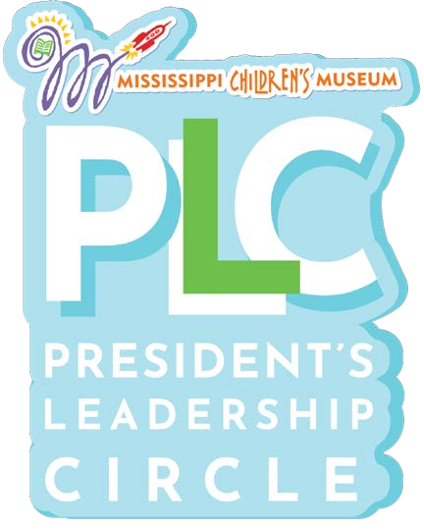


APPLICATION MATERIALS
Please submit all application materials to

Jaylen McDaniels
Volunteer Coordinator
Mississippi Children’s Museum
2145 Museum Boulevard | Jackson, MS 39202
jaylen@mcm.ms | 601.709.8976

Selection will consider service history, reliability, initiative, reflection, respectful leadership, realistic availability, recommendation quality, and application completeness.

STUDENT APPLICATION
President’s Leadership Circle Program

PARTICIPANT INFORMATION
Legal First Name | Preferred Name | Last Name
Type here. | Type here. | Type here.

Date of Birth | Grade for 2026-2027 | Pronouns (optional)
Type here. | Type here. | Type here.

Home Address | City | State | ZIP
Type here. | Type here. | Type here. | Type here.

Student Cell Phone | Student Email Address
Type here. | Type here.

SCHOOL INFORMATION
School | Current GPA (optional) | Expected Graduation Year
Type here. | Type here. | Type here.

School Counselor / Advisor | Counselor Email or Phone
Type here. | Type here.

Advanced, gifted, dual-credit, career/technical, or other specialized coursework (optional)
Type response here.

Extracurricular activities, employment, church/community involvement, or family responsibilities. Include leadership roles and approximate time commitments.
Type response here.

Awards, recognition, certifications, or special skills
Type response here.

STUDENT APPLICATION – cont.
President’s Leadership Circle Program

PARENT/GUARDIAN INFORMATION
Parent/Guardian Name | Relationship to Student
Type here. | Type here.

Primary Phone | Email Address
Type here. | Type here.

Secondary Parent/Guardian (optional) | Phone / Email
Type here. | Type here.

SERVICE HISTORY AND MCM EXPERIENCE
Describe your previous volunteer or community service experience. Include organization, role, dates, responsibilities, and approximate hours.
Type response here.

What did you learn from your most meaningful service experience?
Type response here.

MCM VOLUNTEER EXPERIENCE
☐ I currently volunteer or have previously volunteered at the Mississippi Children's Museum.
☐ I have not volunteered at MCM before.

Name Used in Volgistics | Email Used in Volgistics
Type here. | Type here.

SERVICE HISTORY AND AVAILABILITY
President’s Leadership Circle Program
If you have served at MCM, list your most common assignments/events and describe one contribution you are proud of.
Type response here.

List recurring obligations that may affect PLC participation. Sports, work, school organizations, church, transportation, family responsibilities, etc.
Type response here.

AVAILABILITY AND COMMITMENT
TIME PERIOD | AVAILABILITY
Weekday afternoons/evenings | ☐ Usually available ☐ Sometimes available  ☐ Rarely available
Saturday mornings/afternoons | ☐ Usually available ☐ Sometimes available  ☐ Rarely available
School breaks/holidays | ☐ Usually available ☐ Sometimes available  ☐ Rarely available
Special museum events | ☐ Usually available ☐ Sometimes available  ☐ Rarely available
How will you manage conflicts and communicate when you cannot attend?
Type response here.

LEADERSHIP & SERVICE RESPONSES
President’s Leadership Circle Program

Answer each question in approximately 100-150 words. Be specific and use your own experiences.
1. Why do you want to join the President’s Leadership Circle, and what do you hope to contribute to MCM?
Type response here.

2. Describe a time you took initiative without being asked. What did you do, and what happened?
Type response here.

3. Describe a time you helped someone feel included, supported, or respected.
Type response here.

LEADERSHIP & SERVICE RESPONSES – cont.
President’s Leadership Circle Program

4. Tell us about a commitment you had to balance with school or other responsibilities. How did you follow through?
Type response here.

5. What is one leadership strength you already have, and what is one skill you want PLC to help you improve?
Type response here.

6. Which PLC pillar connects most strongly to you right now, and why?
Type response here.

LEADERSHIP ESSAY
President’s Leadership Circle Program

PROMPT: Describe a time you led by example. Explain the situation, the actions you took, the impact on other people, what you learned about leadership, and how that lesson would shape the way you serve at the Mississippi Children's Museum.
Write approximately 400-500 words. You may type your essay and attach it, or use the space provided. Typed essays should be double-spaced in a clear, readable 12-point font.

Type response here.

LEADERSHIP ESSAY
President’s Leadership Circle Program

Type response here.

STUDENT CERTIFICATION
☐ I certify that the information in this application is accurate and that the written responses are my own work.
☐ I understand that submission does not guarantee selection and that MCM may review my volunteer record when applicable.
Student Signature | Date
Type here. | Type here.

STUDENT COMMITMENT FORM
President’s Leadership Circle Program

By signing, I agree that, if selected, I will:
☐ Participate fully in approved PLC sessions, service opportunities, projects, reflections, and special events.

☐ Follow the MCM Volunteer Manual, staff instructions, safety procedures, Codes of Behavior, and group working agreements.

☐ Treat participants, guests, staff, volunteers, speakers, partners, and cultures with respect.

☐ Arrive on time, sign in and out correctly, and communicate as soon as possible when a conflict, emergency, or delay occurs.

☐ Complete the service-hour and attendance requirements approved for the 2026-2027 PLC year.

☐ Use my cell phone only when permitted and maintain professional appearance and conduct while representing MCM.

☐ Accept feedback, take responsibility for my actions, and work toward personal educational and leadership goals.

☐ Keep my parent/guardian informed about schedules, transportation needs, forms, and program expectations.

☐ Protect confidential information and follow MCM media/photo rules while volunteering.

☐ Understand that repeated absences, poor communication, policy violations, or unsafe conduct may affect my participation or completion status.
Print Student Name
Type here.

Student Signature | Date
Type here. | Type here.

PARENT COMMITMENT FORM
President’s Leadership Circle Program

I give permission for my student to participate in the Mississippi Children’s Museum President’s Leadership Circle, if selected. I understand that:
☐ PLC includes leadership sessions, museum volunteer service, community projects, guest speakers, reflections, special events, and possible field trips.

☐ I am responsible for arranging or providing reliable transportation unless MCM communicates an approved alternative for a specific activity.

☐ I will review program communications, help my student meet deadlines, and notify the PLC Coordinator of important changes or concerns.

☐ My student must follow MCM volunteer, attendance, safety, conduct, confidentiality, dress, and cell-phone policies.

☐ Emergency, medical, transportation, field-trip, participation, and media forms will be completed after acceptance.

☐ Participation may be reviewed if my student repeatedly misses commitments, fails to communicate, or violates program/MCM policies.

☐ MCM may use Volgistics to document attendance, service, progress, verification, and recognition.

Student Name | Parent/Guardian Printed Name
Type here. | Type here.

Parent/Guardian Signature | Date
Type here. | Type here.

Best Phone | Best Email
Type here. | Type here.

NOMINATION FORM
President’s Leadership Circle Program

This form should be completed by a teacher, counselor, coach, supervisor, mentor, faith/community leader, or another adult who knows the student well. Family members should not complete the recommendation.
Student Name
Type here.

Recommender Name | Title / Occupation
Type here. | Type here.

Organization / School | Email | Phone
Type here. | Type here. | Type here.

Relationship to Student | How Long Have You Known the Student? | Contact Frequency
Type here. | Type here. | Type here.

1. Describe the student's potential to lead and serve others. Please provide a specific example.
Type response here.

2. Describe a time the student demonstrated reliability, initiative, work ethic, or follow-through.
Type response here.

3. How does the student respond to feedback, challenges, or working with people who are different from them?
Type response here.

NOMINATION FORM – cont.
President’s Leadership Circle Program

What area of growth should PLC help this student strengthen?
Type response here.

Please Rate | Above Average | Average | Developing | Unable to Rate
Reliability and punctuality | ☐ | ☐ | ☐ | ☐
Follows through on commitments | ☐ | ☐ | ☐ | ☐
Takes initiative | ☐ | ☐ | ☐ | ☐
Works respectfully with diverse people | ☐ | ☐ | ☐ | ☐
Service mindset / willingness to help | ☐ | ☐ | ☐ | ☐
Communicates clearly | ☐ | ☐ | ☐ | ☐
Accepts feedback | ☐ | ☐ | ☐ | ☐
Shows emotional maturity | ☐ | ☐ | ☐ | ☐
Works cooperatively | ☐ | ☐ | ☐ | ☐
Speaks in front of others | ☐ | ☐ | ☐ | ☐
Manages time effectively | ☐ | ☐ | ☐ | ☐
Demonstrates leadership potential | ☐ | ☐ | ☐ | ☐
Additional comments or concerns the selection team should consider
Type response here.

☐ I strongly recommend this student.
☐ I recommend this student.
☐ I recommend this student with reservations explained above.
☐ I am unable to recommend this student at this time.
Recommender Signature | Date
Type here. | Type here.

